OOP LAB TASK 2

QUESTION 1

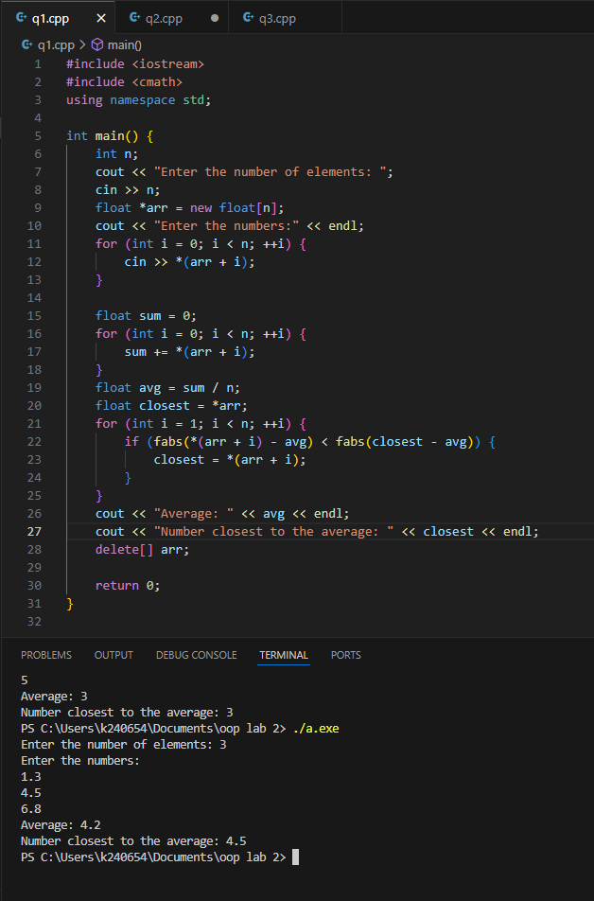

Q2

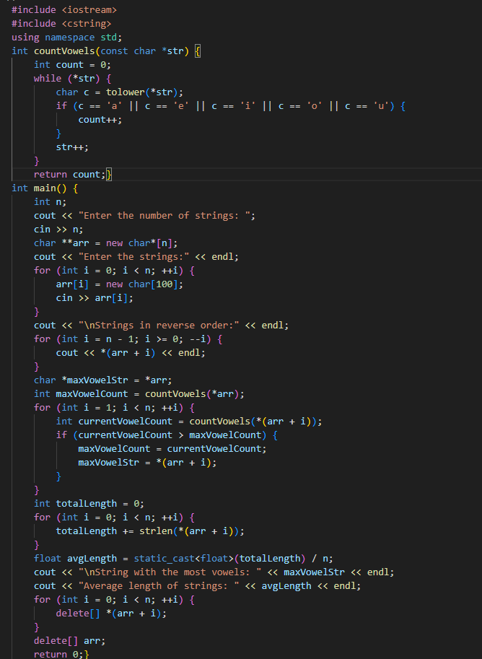

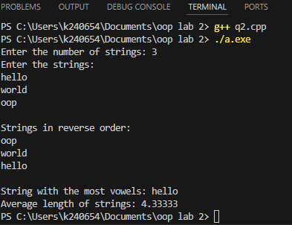

Q6

Input:

#include <iostream>

using namespace std;

typedef struct Register {

    string courseId;

    string courseName;

} Register;

typedef struct Student {

    string studentId;

    string firstName;

    string lastName;

    string cellNo;

    string email;

    Register registration;

} Student;

int main() {

    int numberOfStudents;

    cout << "Enter the number of students: ";

    cin >> numberOfStudents;

    cin.ignore();

    Student\* students = new Student[numberOfStudents];

    for (int i = 0; i < numberOfStudents; ++i) {

        cout << "Enter details for student " << i + 1 << ":\n";

        cout << "Course ID: ";

        cin >> students[i].registration.courseId;

        cin.ignore();

        cout << "Course Name: ";

        getline(cin, students[i].registration.courseName);

        cout << "Student ID: ";

        cin >> students[i].studentId;

        cout << "First Name: ";

        cin >> students[i].firstName;

        cout << "Last Name: ";

        cin >> students[i].lastName;

        cout << "Cell Number: ";

        cin >> students[i].cellNo;

        cout << "Email: ";

        cin >> students[i].email;

        cout << endl;}

    cout << "\nDisplaying information of all students:\n";

    for (int i = 0; i < numberOfStudents; ++i) {

        cout << "Student " << i + 1 << " Details:\n";

        cout << "Course ID: " << students[i].registration.courseId << endl;

        cout << "Course Name: " << students[i].registration.courseName << endl;

        cout << "Student ID: " << students[i].studentId << endl;

        cout << "First Name: " << students[i].firstName << endl;

        cout << "Last Name: " << students[i].lastName << endl;

        cout << "Cell Number: " << students[i].cellNo << endl;

        cout << "Email: " << students[i].email << endl;}

    delete[] students;}

output:

